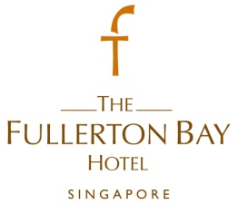
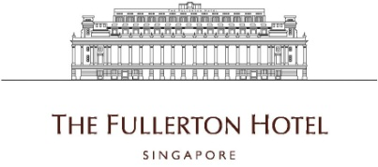

Events Manager
- Ensure that Food & Beverage outlets are managed financially successfully as independent profit centre by driving and soliciting various events opportunities.
- Fully responsible and accountable for the F&B outlets events revenues and profitability and to ensure that the Department's operational budget is strictly adhered to and that all costs are controlled and expenditure approved.
- Continuously seek ways to assist the F&B department to maximise their revenues and profits through sales calls, networking events, partnerships and cooperation.
- Communicate on a regular basis with the Director of F&B (FBH) & F&B Manager (FHS) to review the outlets’ event revenues and activities and achieve the set targets
- Propose new financial avenues and trends for events and effective outlet positioning.
- Work closely with the Catering team to explore and maximise events opportunities within The Fullerton Heritage precinct.
- To be the key contact person for any event enquiries and perform all the necessary follow-up to ensure all events are carried out successfully.
- Prepare events contracts and to secure deposits and maintain established credit policies.
- To be familiar and comply with local legislation for any event execution.
- Ensure that all the F&B events are managed efficiently according to the established concept statements and adhere to Hotel Policies & Procedures and Minimum Standards.
- Prepare event order according to guest specifications and ensure coordination and communication with both internal and external parties concerned.
- Prepare a monthly definite booking report at the conclusion of each week.
- Provide and coordinate details of daily events with the F&B service and culinary team.
- Establish good rapport with events organiser, maintaining good relationship and handle all feedback, requests and enquiries on food, beverage and service

Requirements :
- Preferably 2 year of experience in F&B.
- Candidate with hospitality experience has an added advantage.
- Pleasant disposition with good interpersonal skills.
- Able to multi-task.
- Able to work in a fast-paced environment
.
.
To apply for the above positions, please send your full resume to careers@fullertonhotel.com.

