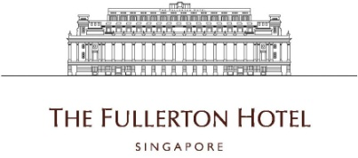

AV Manager
- Ensures audio visual equipment is fully operational
- Attend to Guestrooms / Common Areas complaints on A/V
- Carries out routine check and logging of Hotel A/V equipments
- Attend to work orders for minor repair of A/V Works.
- Manages staff and operations of audio-visual department
- Has responsibility for ordering, procurement, receipt, inventory, maintenance delivery, distribution and expert troubleshooting of all audio-visual and multimedia equipments
- Schedules assigns and prioritizes workloads and sets appropriate deadlines
- Conducts training regarding proper usage and operation of AV equipment

Requirements :
- 5 years’ of relevant working experience
- Good communication and interpersonal skills
- Able to work independently under tight deadline
- Able to work rotating shifts including weekends and public holidays.

To apply for the above positions, please send your full resume to careers@fullertonhotel.com.

