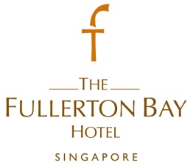
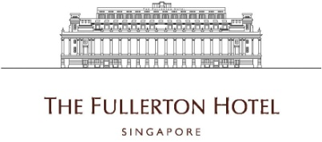

IT Manager
- Administer and maintain information technology systems (including PC and LAN equipment).
- Provides IT operation functions to user on standard hardware, software and voice/data network solutions.
- Responsible for the purchase, installation, and life-cycle maintenance of PCs, servers and LAN network connectivity equipments.
- Provides escalated on-site support of hardware, software and network connectivity issues.
- Performs local administration and operation functions as appropriate in accordance with standards, policies and procedures.
- Responsible for local inventory maintenance and software license management.
- Responsible for procurement, installation and life-cycle maintenance of IT hardware and software (includes PCs, peripherals, servers, networking equipment, operating systems and other software)
- Provides new staff with PC/account setup and orientation of new staff
- Responsible for monitoring data backups in offices to ensure that they are completed on a regular basis.
- Analyses the Hotel’s computerization needs and problems and advises on feasibility of various automatic data processing systems. He will also make recommendations on appropriate systems and procedures accordingly.
- Co-ordinates and implements the Hotel’s computerization plans and activities.
- Evaluates and plans software configurations for specific applications and needs of various departments.
- Plans, develops and establishes sequence of steps for data input/ output and computer processing operations, taking into account internal checks and other controls needed to ensure integrity and security of computerized information.
- Monitors, advises and assist users on methods of recording, processing and retrieving control information, including new methods.
- Supervises and trains users on operating and controlling computers and its related equipment in accordance with established or new operating procedures, in order to ensure smooth flow of computer operations and successful completion of jobs.
- Plans, schedules and carries out regular maintenance checks and ensures preventive maintenance of all computers and its related equipment.

Requirements :
- Diploma in Information Technology, or equivalent fields
- 5 years of experience in relevant job scope
- Good interpersonal and communication skills
To apply for the above positions, please send your full resume to careers@fullertonhotel.com.

