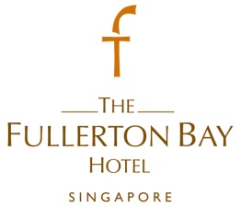
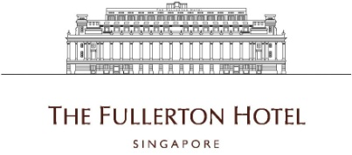

Assistant Banquet Manager
- To train, motivate, discipline and supervise the work of the employees in Banquet Team
- Ensure all staff are well groomed with strict adherence to the Hotel’s standards.
- Ensure proper care, security and maintenance of hotel equipment through proper supervision of service personnel.
- Respond swiftly in any hotel emergency or safety situation.
- Build close working relationship and effective communication with catering sales personnel and other departments in regards to daily requirements for contracted functions.
- Ensures that F&B control procedures are adhered to and that all food and beverage are issued with proper chits of charging.
- Attend to guest complaints, problems or situation and take prompt, corrective action, ensuring the highest degree of guest satisfaction.
Requirements :
- Minimum 3 years of relevant experience
- Customer oriented
- Possessed leadership skills
- Good interpersonal skills
- Applicants must be willing to work shift duties including weekends and public holidays

To apply for the above positions, please send your full resume to careers@fullertonhotel.com.

